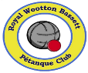  ***Royal Wootton Bassett Petanque Club***

***National Success for RWB PC.*** RWB PC teams really put the Club and the Town on the Petanque national map. Finals and Semi-final squads won their way through to be the ultimate winners in this national competition competing over a 9-month period against teams on a regional and national knock-out basis. Pictured below is the whole squad at different venues.

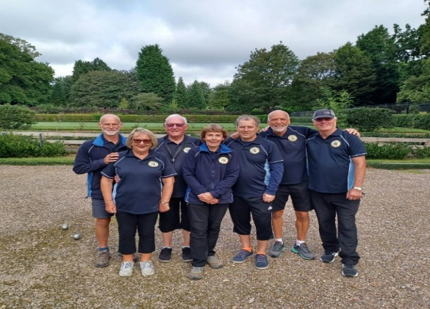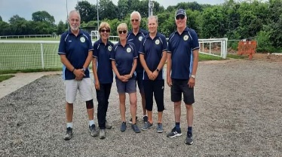

The finals played in Leicestershire saw play against 4 teams all going for the national Euro Cup Plate. RWB PC came out the winners! **A first National competition win for the Club.**

RWBPC was well represented in teams competing in the National Inter-Regions in Pakefield, Suffolk which saw nearly 1,000 people playing 2 full days of Petanque. The Challenge Squad won promotion to Division 1.

Other success saw RWB PC members win 2 Silver finals in both the GWR Doubles and the GWR Triples Regional competitions – Well done to both teams.

In the inter county competition, the Division 1 team, RWB Royals retained the Cotswold Championship Shield for the 2nd year running. In Division 2, Bassett Allsorts gained promotion to Division 1 so go head-to-head with the RWB Royals next year- watch this space for results.

Mid-October saw us hosting ***Round 1 of the RWB Sports Association ‘Sports Challenge’*** where all Clubs at the RWBSA played Petanque against each other. It was a very fun filled, competitive evening with all Clubs well represented - Cricket, Football, Running, Tennis, Exec team, and Petanque each saying how good it was to interact with other sports at RWBSA. No prizes if you guessed the winners of Round 1 - (RWBPC) but let’s see what happens in all the other sports with Round 2 coming in the late Autumn and Spring time.

Members travelled to Somerset and North Devon for the annual ‘Cream Tea Petanque Tours’ playing both at the new Club in Weston Super Mere and at the prestigious The Royal North Devon Golf Club.

Charity fundraising by Members and guests raised £390 from the Macmillan Coffee morning held in September. Cakes and more cakes were enjoyed, a silent auction raised £20 for a special fruit cake by Jan B. Thanks to all for supporting this cause.

The RWB PC Autumn Melee was a success with cash prizes going to the top 4 players. For some members this was their first competition and all enjoyed having to raise their game against the more experienced players.

New players who wish to compete in a relaxed and affordable sport are welcome. We would also welcome offering our sport to young people with coaching given and free membership (7-18years).

**Sessions -Tuesdays/Fridays -** 10 am- 12 noon, **Tuesday evenings** 7 to 9pm. **Saturday morning 10 am –12 noon. *Facebook: RWB PC - Contact:*** [***AlanMcInnes1@outlook.com***](mailto:AlanMcInnes1@outlook.com) ***or marionsweet4@aol.com***